GIT

It is a version control system developed to co-ordinate the work among the developers.

Version Control System: A version control system is a software that tracks changes to a file or set of files over time so that you can recall specific versions later. Everyone has the copy of the repo

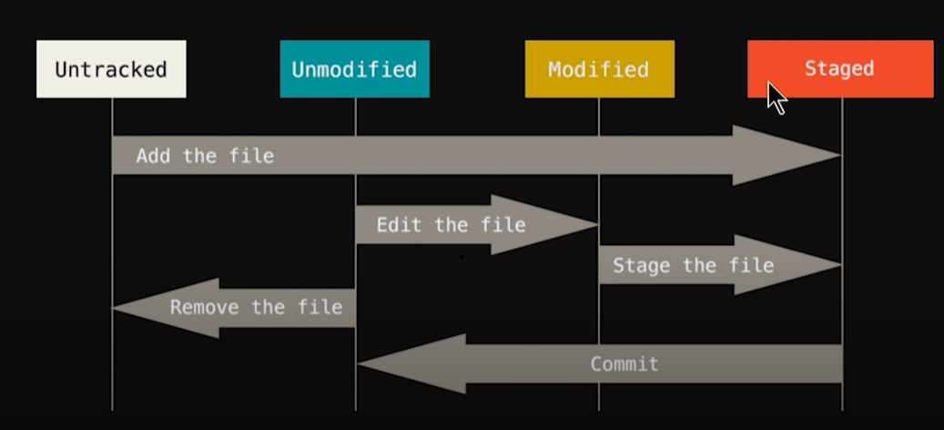

Untracked Files: Whenever Git finds a new file inside the application folder, it is considered an Untracked File by Git, because Git doesn't know the file until we explicitly tell it about that file.
So, to let Git know about the file, we stage the file and commit or push it into the repository and make it a tracked file.

Git status---> Check the status of file modified/untracked etc.
Git add/git add -A ---> Staged file.
Git commit -m "Intial Commit" ---> Commit the file along with message.
Git checkout/git checkout -f ---> To match the file with the last commit. Used in recovering of the file.
Git log/git log -p -1---> Shows the history of commit alongwith the message.
Git diff ---> It will compare working tree with the staging area.

